**Module 2 Kinematics of particles**

**Variable motion**

**1.** A loaded railroad car is rolling at a constant velocity when it couples with a spring and dashpot bumper system. After the coupling, the motion of the car is defined by the relation x=60e-4.8t sin16t where x and t are expressed in mm and seconds, respectively. Determine the position, the velocity and the acceleration of the railroad car when (a) t = 0, (b) t = 0.3 s.

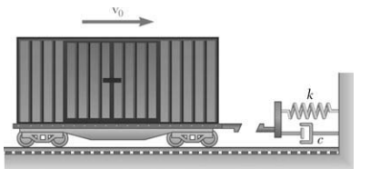

2. The acceleration of a particle is directly proportional to the square of the time t. When t = 0, the particle is at x = 24 m. Knowing that at t x = = 6 s, 96 m and v =18 m/s, express x and v in terms of t.

3. The acceleration of a particle is defined by the relation a= kt2(a) Knowing that v = −8 m/s when t = 0 and that v = +8 m/s when t = 2 s, determine the constant k. (b) Write the equations of motion, knowing also that x = 0 when t = 2 s.

4. The acceleration of Point A is defined by the relation a = −1.8sin(kt) , where a and t are expressed in 2 m/s and seconds, respectively, and k = 3 rad/s. Knowing that x = 0 and v = 0.6 m/s when t = 0, determine the velocity and position of Point A when t = 0.5 s.

5. A piece of electronic equipment that is surrounded by packing material is dropped so that it hits the ground with a speed of 4 m/s. After contact the equipment experiences an acceleration of a = -kx where k is a constant and x is the compression of the packing material. If the packing material experiences a maximum compression of 20 mm, determine the maximum acceleration of the equipment.

6. The acceleration of a particle is defined by the relation a= −0.8v where a is expressed in m/s2 and v in m/s. Knowing that at t = 0 the velocity is 1 m/s, determine (a) the distance the particle will travel before coming to rest, (b) the time required for the particle’s velocity to be reduced by 50 percent of its initial value.

7. The car in Fig moves in a straight line such that for a short time its velocity is defined by v = (3t² + 2t) m/s, where t is in seconds. Determine its position and acceleration when t = 3 s. When t = 0, s = 0.

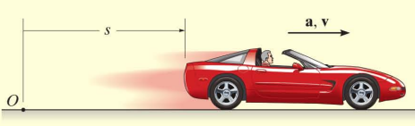

8. A small projectile is fired vertically downward into a fluid medium with an initial velocity of 60 m/s. Due to the drag resistance of the fluid the projectile experiences a deceleration of a = (-0.4v3) m/s², where v is in m/s. Determine the projectile's velocity and position 4 s after it is fired.

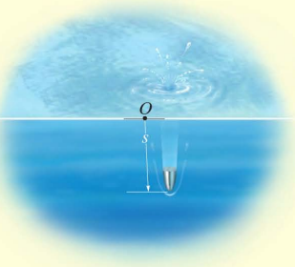

9. A metallic particle is subjected to the influence of a magnetic field as it travels downward through a fluid that extends from plate A to plate B, Fig. If the particle is released from rest at the midpoint C, s = 100 mm, and the acceleration is a = (4s) m/s², where s is in meters, determine the velocity of the particle when it reaches plate B, s = 200 mm, and the time it takes to travel from C to B.

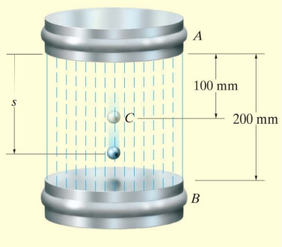

10. The acceleration of particle is given by a =25 – 3x2.If the particle starts from rest and from origin Find (1) The velocity when x = 2 mm (2) The position when velocity is again zero (3) Position where velocity is maximum and corresponding max velocity.